Name: ___________________________

Student number: ___________________________

Test 4

Read through the entire assignment first before implementing code. It is essential to clearly understand what’s expected and what your final experiment should look like.

Practical tips:

- Put the general structure of the experiment on paper before starting.

- Do not forget to regularly run your experiment after adding new elements. This will ease the process of debugging your code (if needed). For a code that runs without errors, you earn **1 point**. Hint: print() can be useful when debugging code.

- Keep a clear structure in your code and do not forget to comment on your code. For clearly structured and commented code you earn **2 points**!

- Even if you do not manage to implement all elements that are asked, it is worth commenting on what you have done or tried. This way you provide us some insight into your programming skills. A partial solution is better than no solution.

- Avoid useless code because that can cost you **1 point**.

General Description

For this test, you must program a decision-making task. On each trial, participants are shown one of four pictures; a yellow apple, a green apple, a yellow banana, or a green banana. You can find four such pictures on Ufora (you don’t have to submit them with your py file). These pictures can appear at a left (25% of the screen), center (50% of the screen), or right (75% of the screen) position. The py file must search for (and find) the pictures in the same directory as the py program itself.

Subjects with an odd participant number, must press “f” for a yellow stimulus and “j” for a green one; this mapping must be reversed for even-numbered participants. A column in the data file called “instruction mapping” should indicate the mapping.

This experiment has 4 blocks. In two of the blocks, only the left and center positions are used; in the other two blocks, only the right and center positions are used. These four blocks are randomly shuffled. In every block, each of the 2*2*2 = 8 possible stimuli are presented equally often, but in a random position.

You must use the ExperimentHandler and TrialHandler to organize, present, and save your data.

Interacting with the participant

- Work on a screen of 800 by 800 pixels.

- Use the norm coordinate system.

- Use a pink background throughout the experiment. Any shade of pink is fine.

- Show all text in white.

- Use the GUI dialogue to collect information about the participant’s number, first name, last name, age, gender (male, female, 3rd gender), and handedness (right, left or both).

- Display a welcome message that addresses the participants by their first name (e.g., “Welcome Tom!”).

- The general task in this experiment is for the participant to respond to the color of the stimulus (yellow or green). Briefly explain the experiment to the participant (one sentence suffices, but make sure each participant receives the correct info based on his/her participant number).

- After the practice phase, show a message that the main experiment is about to begin.

- End the experiment with a screen that shows the participant’s accuracy (as a percentage, 0-100%), and thanks the participant for their participation. You should also use the participant’s first name in this message, just like you did with the welcome screen (e.g., “Thanks for participating, Tom!”).

- The participant should use the spacebar to proceed after the welcome, instruction, goodbye screens and after the practice phase. Make sure to indicate on each of these screens that only the space key should be used to continue.

Implement a minimal trial

* Per trial, the participant gets to see a single yellow or green apple or banana, possibly lateralized. An example follows below:

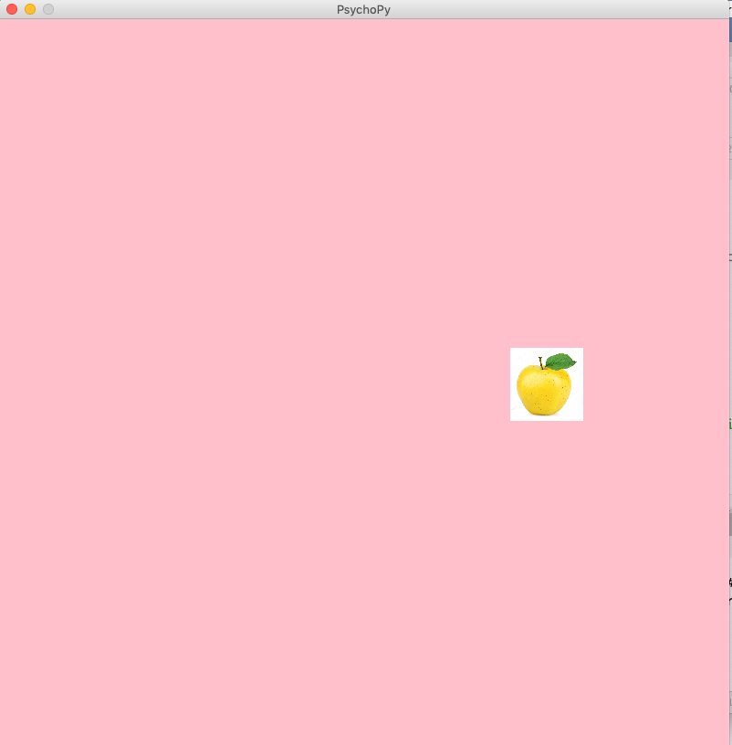

* You can choose the stimulus size, but it must be “reasonable” (not extremely large or small).
* The participant can answer by pressing ‘f’ or ‘j’ (cf. above): The trial ends when the participant presses any of these two keys. Make sure no other keyboard responses are allowed, except the possibility to escape from the experiment by pressing the ‘q’ key.
* All trials must be followed by appropriate feedback, either “Correct!”, “Wrong” or “Too slow!” for 400 msec. The deadline for responding is 1500 msec.

Data accountancy

* Before proceeding to stimulus presentation, check your randomization with a cross table. Its rows must be the type of fruit (apple or banana), its columns color (yellow or green).
* For every trial, save the relevant information (response, accuracy, RT) via the trial- and experimenthandler.
* A block should never start with a yellow apple (this restriction does not apply to the practice phase).
* The block number, block type (i.e., is the left or right horizontal position used?), and correct response for each trial, must all be saved as (3) separate columns in the data file.

Experiment structure

* There are 16 trials in one block. Per trial, one of the 8 possible stimuli for that block is selected. Stimuli per block must be randomly shuffled.
* There are 4 blocks. Note that there are two block types (i.e., is the left or the right location used in this block?): Their order is randomly shuffled.
* You must present all messages (including trial feedback) to the participant via a function.
* The experiment starts with a single practice block where you present the trial numbers 4, 6, and 8 in a random order.

Submission

Save your code as lastname_firstname_test4.py. Go to ‘Instruments of Experimental Psychology’ on Ufora and continue to ‘Ufora-Tools’ and ‘Assignments’. Select ‘Test 4 – PsychoPy Coder’. Use Add new file’ to upload your script and click ‘submit’.

Let us know that you have submitted your file so that we can check your file. We will note your name for participation. **Hand in both pages of the assignment before leaving the room.**